### Unified Messaging Voicemail

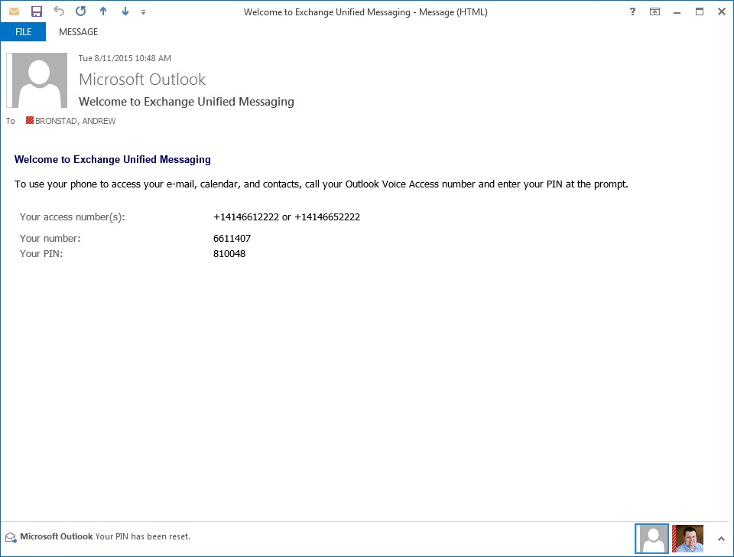

### **Getting started**

### **Record your voicemail message**

1. From Outlook, open the “Welcome to Exchange Unified Messaging” email.
   1. Dial the access number (xxx-xxx-xxxx).
   2. Enter your temporary pin followed by [#].
2. Follow the prompts to record your name and greeting.   
   *NOTE: If you already provide callers the option dial ‘0’ for   
   immediate assistance, include this information in your new personal greeting.*

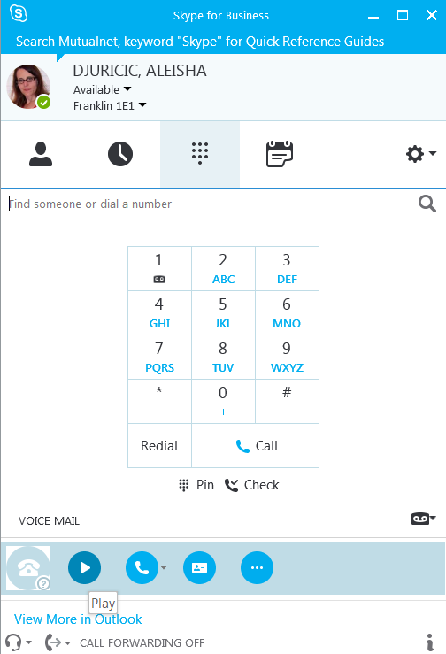

### Listen to voicemail - from SkypeFrom the Skype dial pad, press and **hold the #1 key** *(for about 5 seconds)* to dial into voicemail.

Listen to voicemail - from Outlook   
Open item in Outlook (double-click). Press the **Play** button to listen to the message.   
(Click **OK** on the Rights Management confirmation box).

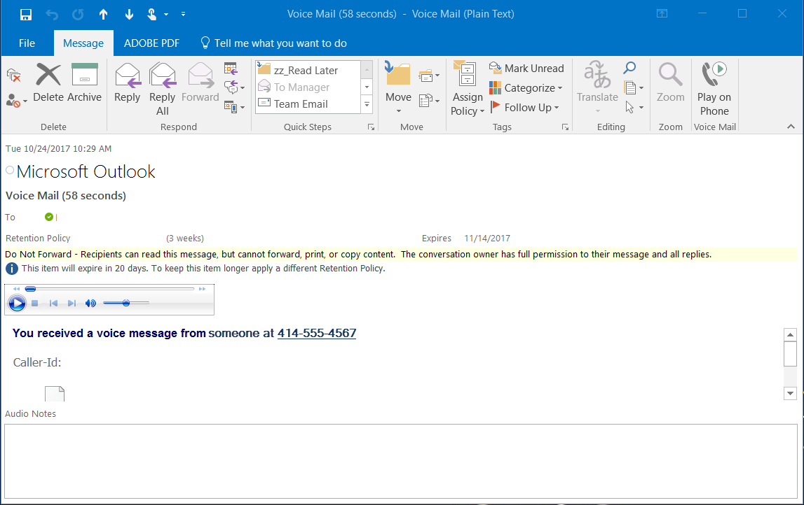Listen to Voicemail - from a Phone  
Dial [xxx-xxx-xxxx]. If prompted, enter your PIN, followed by [#]. Follow the prompts, either speak or press the dial pad for options.   
*The option to reply back with a voicemail is available for internal messages only.*

Alternatively, click the **Play on Phone** button to listen to a voicemail.   
The **Play on Phone** window appears – click **Dial**, then **Accept** the “toast-pop.”

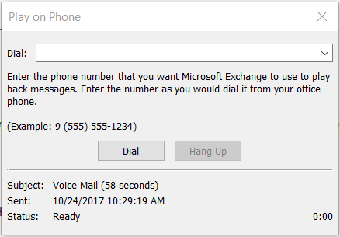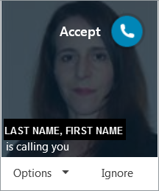

Leave a Voicemail for Multiple People (internal only)  
Dial [xxx-xxx-xxxx]. If prompted, enter your PIN, followed by [#]. Press 5 to send a voicemail. Press # to enter 7-digit extension.   
Press 1 to record the message. Follow the menu prompts (press 2) to add another user/extension. *For additional options (such as marking the message as ‘important)’ follow the prompts.*

#### **Manage Voicemail**

1. From Outlook, go to **File > Manage Voice Mail.**

**Voicemail messages remain for 21 days**Messages will be deleted after 21 days, even if they are unread.

**Voicemails cannot be forwarded**

1. **OWA will launch in a browser. [URL]**
2. **Login to OWA:**   
    user ID: abd1234  
    user password: xxxxxxxx

**RESET PIN:**Click the **Reset my voice mail PIN** link. *(A new, temporary PIN will be sent via email to your inbox.)*

*If you do not see the screen below and are only seeing the OWA email message screen, click on the drop down “****Options****” on the far right of your OWA and choose “****see all options****”. That will open up a new screen, click on “****Phone****” to display the Voice Mail tab which will display the informational screen below.*

**GREETINGS:** (default or extended absence (temporary) greeting)  
In the **Voice Mail** section, under **Choose the greeting played to callers**, select the greeting to play, click **SAVE.**

**NOTIFICATIONS:**Receive a "Missed Call" notification to your email when a caller doesn't leave a voice message.   
To turn this feature **off**, **uncheck the box** in the Outlook Web App Notifications area, click **SAVE.**

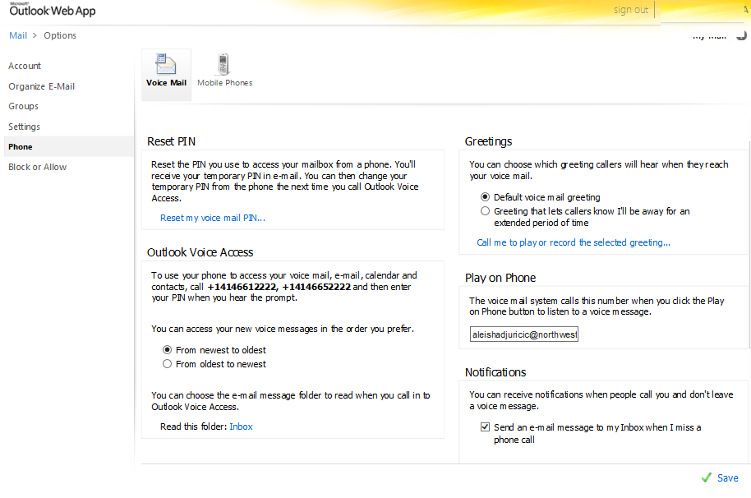



##### Change PIN

1. Dial into voicemail. Select “**Personal Options**” when you hear the prompt.

Pin numbers must be at least 6 digits long.   
You cannot reuse the last five pins.

1. Select **pin** (option 3) and enter a new pin number.

##### Additional Options via Phone (Advanced Phone Users)

Want even more options via your dial pad? Check out the [Outlook Voice Access reference guide](http://community.nml.com/sites/ITPS/uc/Skype%20for%20Business%20Lync/OutlookVoiceAccess-Dial%20Pad%20Codes.pdf) for dial pad codes that allow   
you to use additional options such as your Outlook Calendar.